**Design overview of Old School Game in C++**

The aim of the project will be to make a rouge-like game in the spirit of Nethack (1987).

**Basic Features**

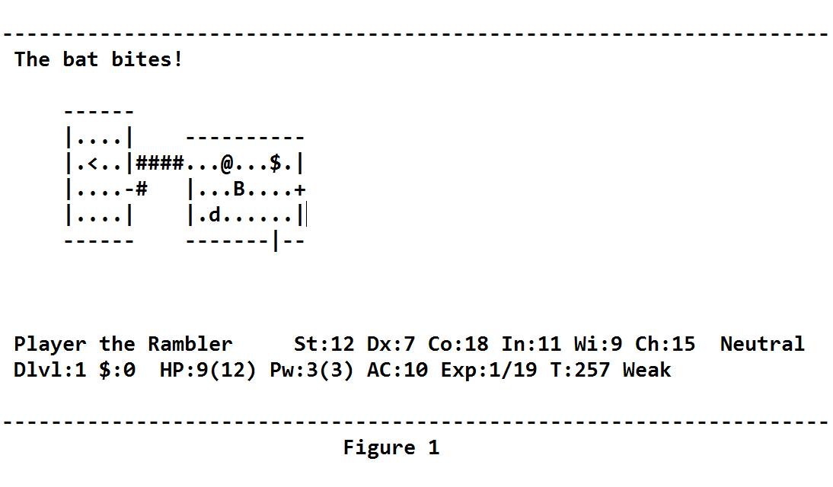

GUI

Player Name, Health, Money, Level, EXP, Weapon, Floor number.

1. Player(@)
2. Item($)
3. Enemy(B)
4. Doors(+)
5. Stairs(<)

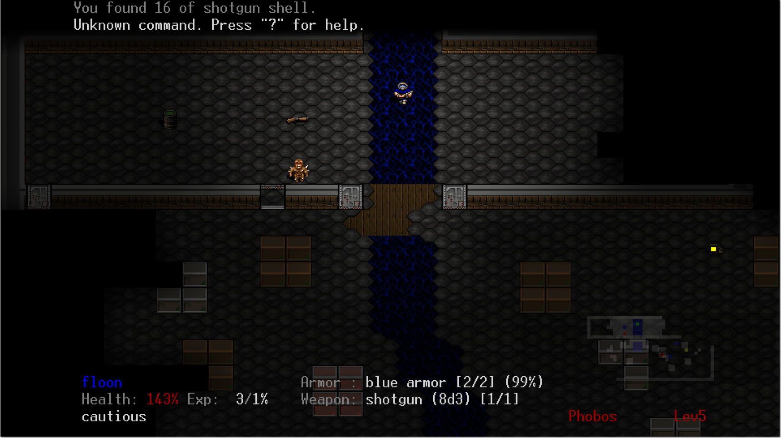

1. **Map design**
2. **Movement**
3. **Doors and stairs**
4. **Items**
5. **Hud stat implementation**
6. **Inventory**
7. **Enemy AI**
8. **Database for saving and levels**
9. Fog of war
10. Leveling system and score
11. Random level design (if not random item placement and random enemy)